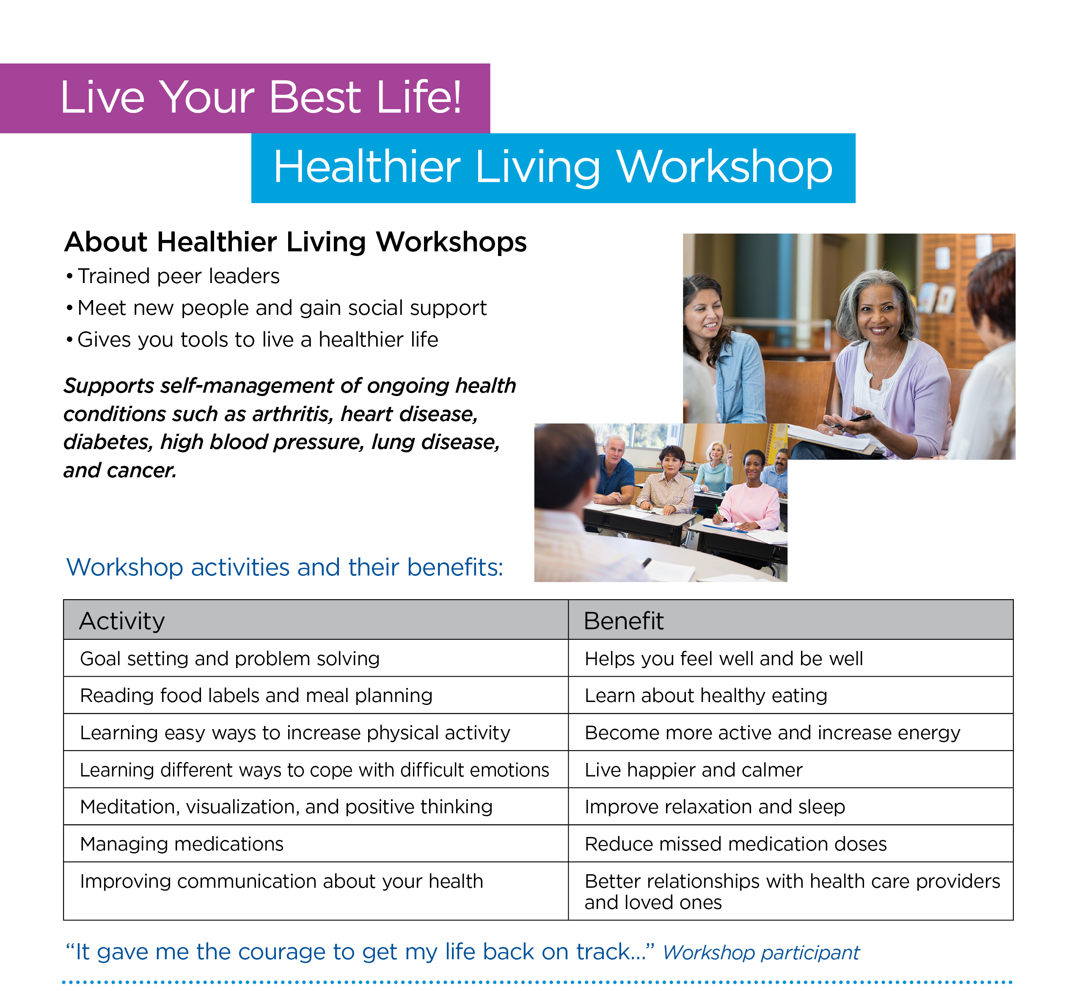

Sign up NOW for this six-week workshop.
Location:
Dates:
Time:
Contact:

